1. Buat database

Database = bank_db

Table = tabungan_tbl

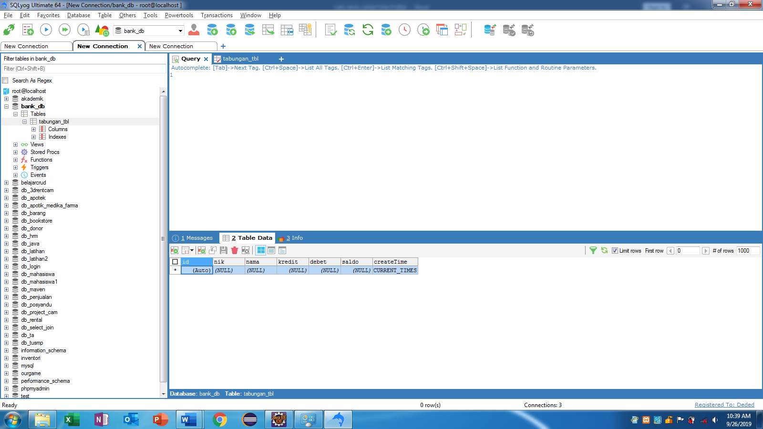

1. Create Project Maven

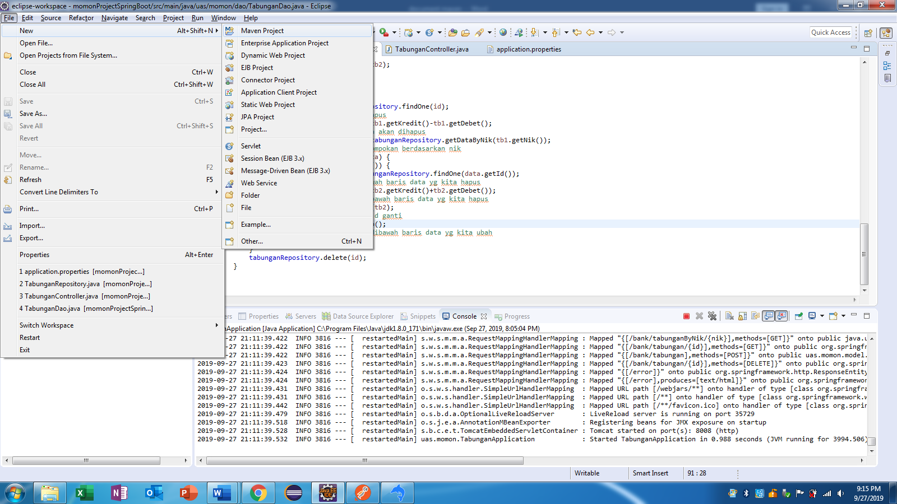

Ketik “webapp” di kolom filter - klik maven - arctype-webapp – next

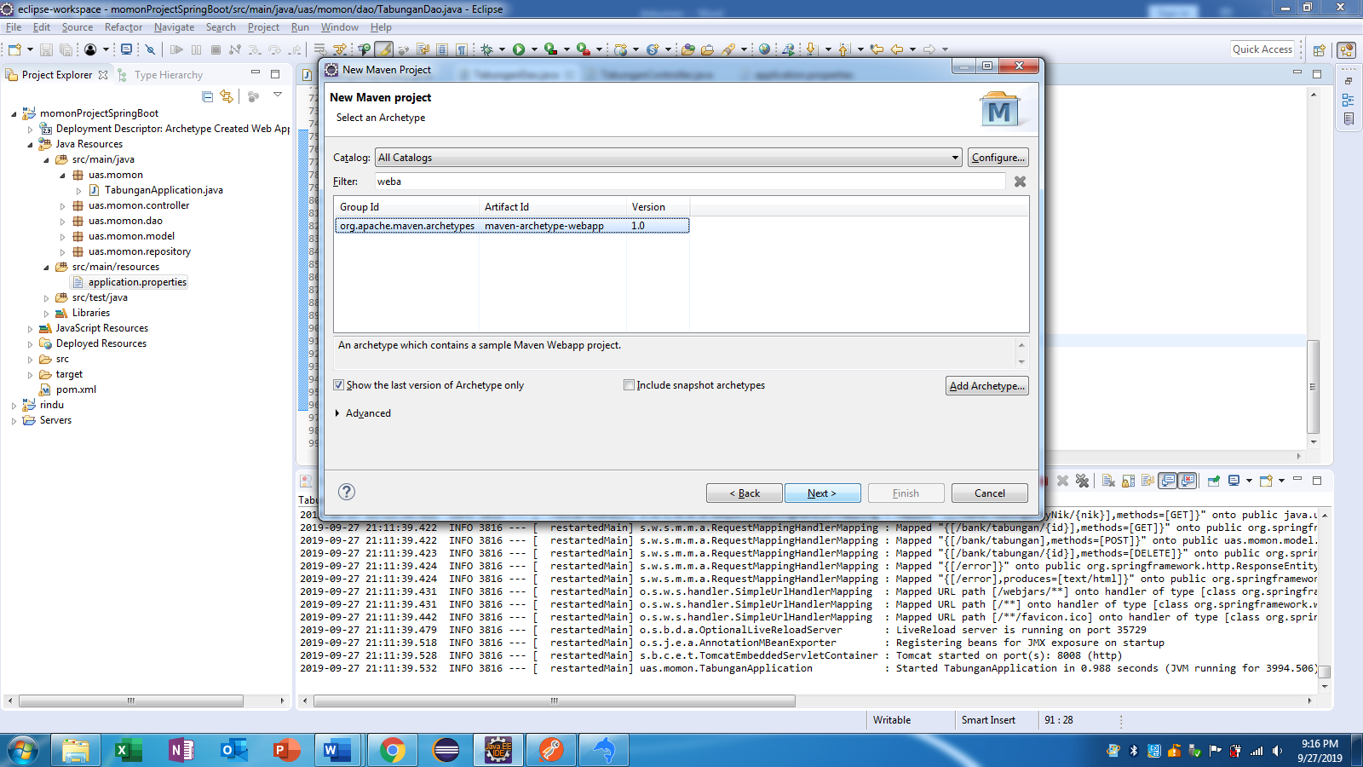

Berinama project

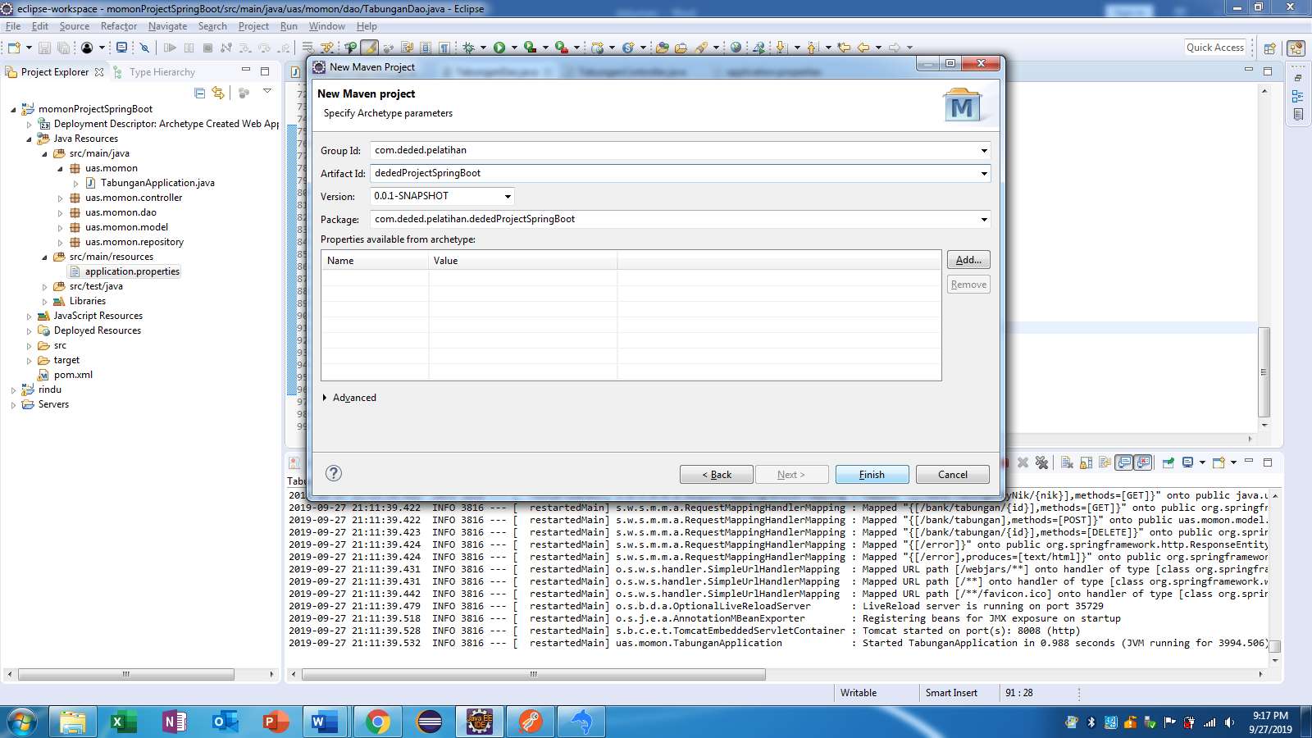

dededProjectSpringBoots Project berhasil di created

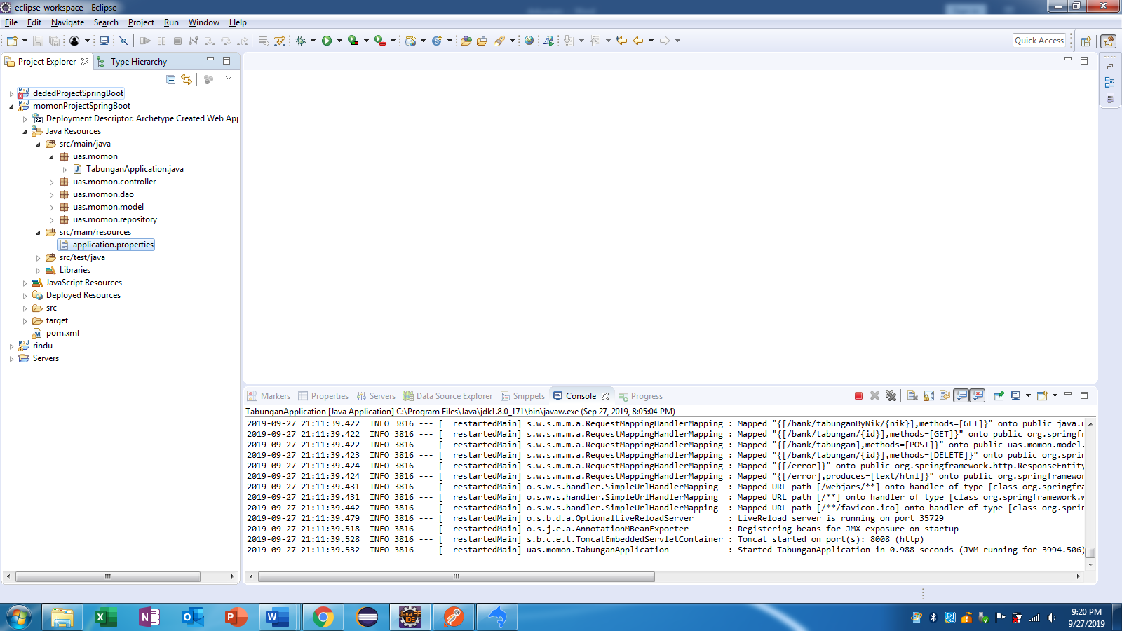

1. Menambahkan kodingan pada pom.xml

Di bawah url

<parent>

<groupId>org.springframework.boot</groupId>

<artifactId>spring-boot-starter-parent</artifactId>

<version>1.5.4.RELEASE</version>

<relativePath/> <!-- lookup parent from repository -->

</parent>

Di bawah </dependency>

<dependency>

<groupId>org.springframework.boot</groupId>

<artifactId>spring-boot-starter-data-jpa</artifactId>

</dependency>

<dependency>

<groupId>org.springframework.boot</groupId>

<artifactId>spring-boot-starter-web</artifactId>

</dependency>

<dependency>

<groupId>org.springframework.boot</groupId>

<artifactId>spring-boot-devtools</artifactId>

<scope>runtime</scope>

</dependency>

<dependency>

<groupId>mysql</groupId>

<artifactId>mysql-connector-java</artifactId>

<scope>runtime</scope>

</dependency>

<dependency>

<groupId>org.springframework.boot</groupId>

<artifactId>spring-boot-starter-test</artifactId>

<scope>test</scope>

</dependency>

1. Tambahkan file database di package java resources. java resources – klik kanan java/main/resources – new-other-general-file

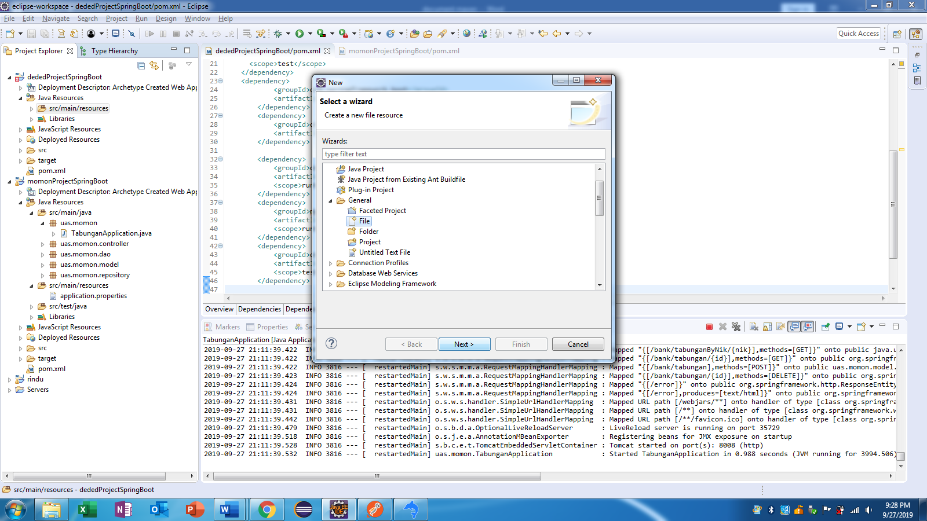

Berinama file dengan nama “application.properties”

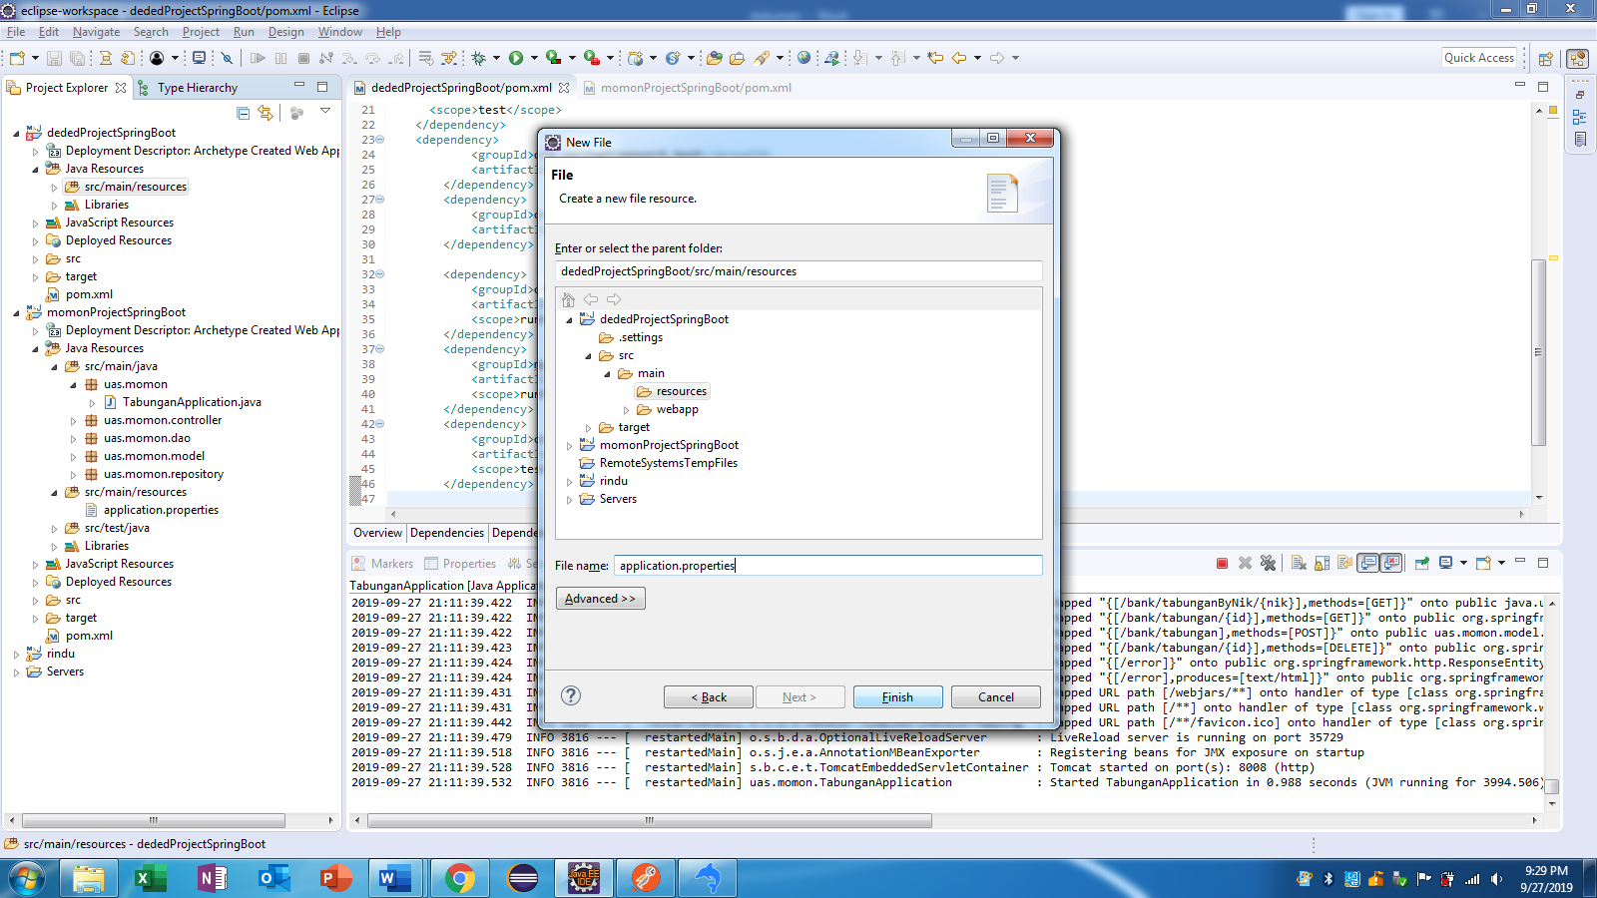

Tambahkan kodingan di file application.properties

------ sesuaikan dengan nama database kita

spring.datasource.url = jdbc:mysql://localhost:3306/bank_db?useSSL=false

spring.datasource.username = root

spring.datasource.password =

spring.jpa.properties.hibernate.dialect = org.hibernate.dialect.MySQL5Dialect

spring.jpa.hibernate.ddl-auto = update

server.port=8085

1. Lalu run project. Klik kanan project kita – run as – maven build.

Akan muncul tampilan dibawah ini. Isi kolom goals = “clean install” – ok

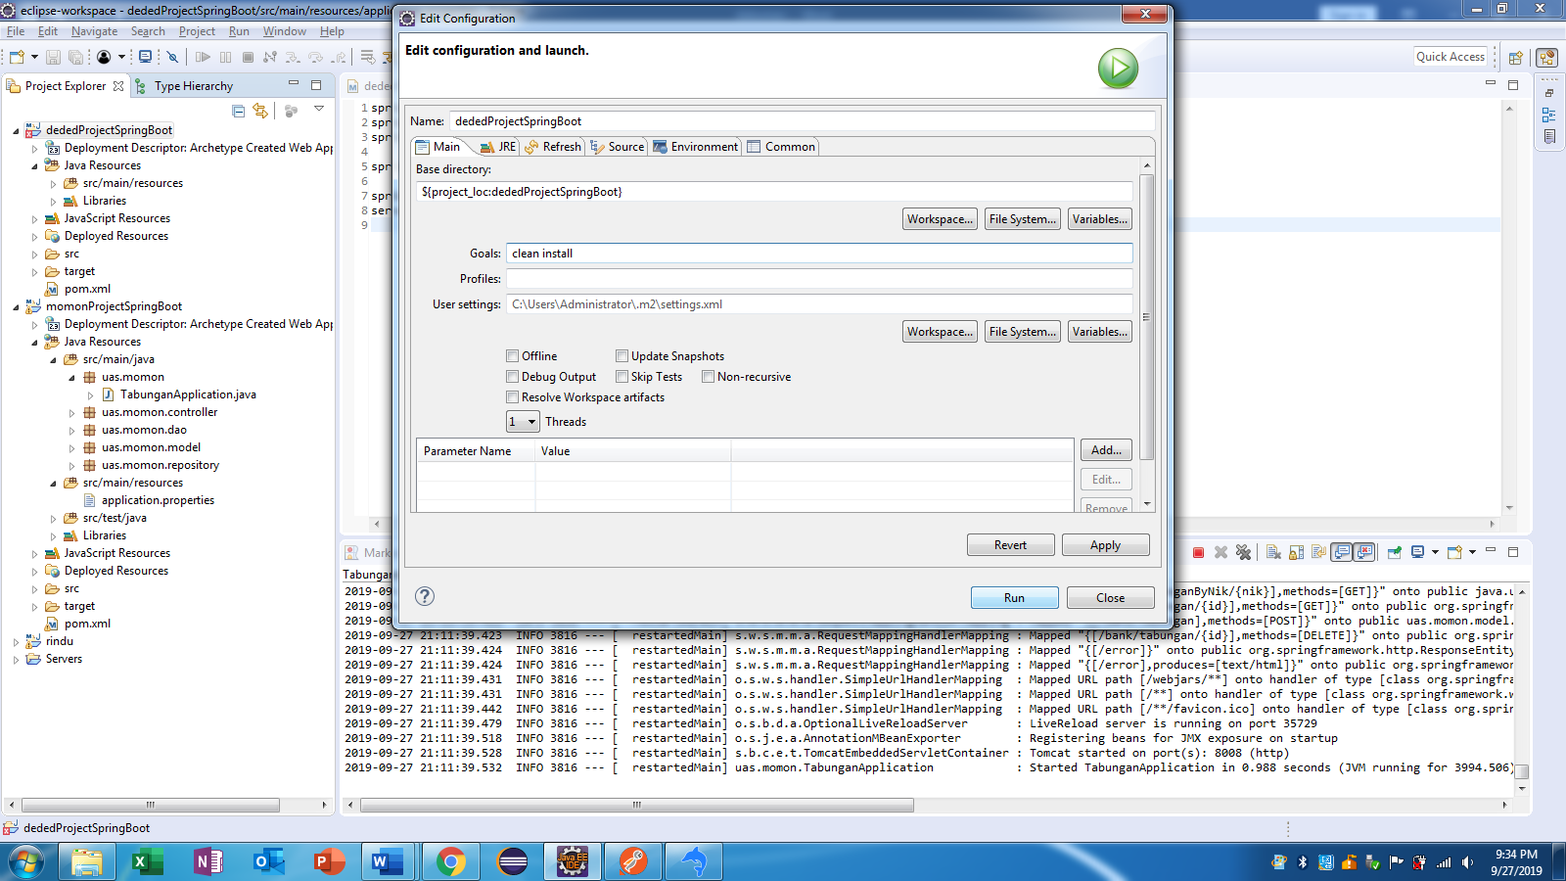

Output

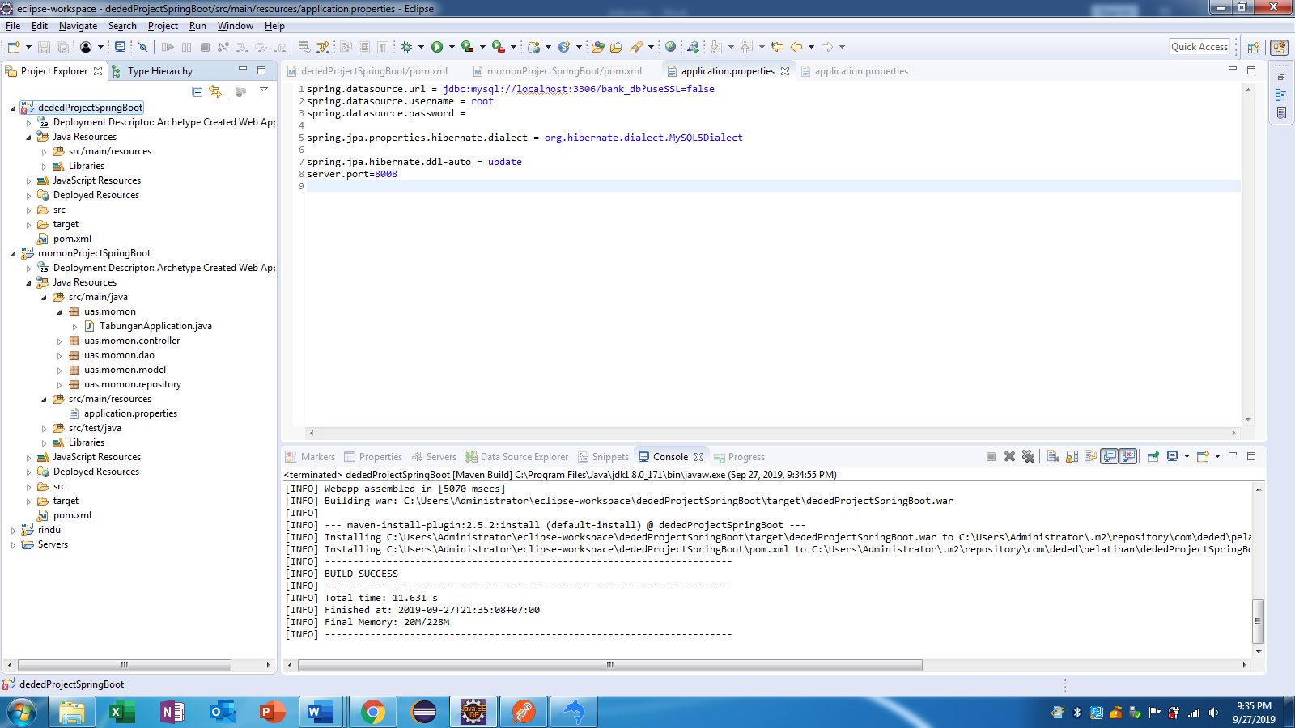

1. Untuk menghilangkan tanda silang merah di project kita, maka klik kanan project – maven – update maven

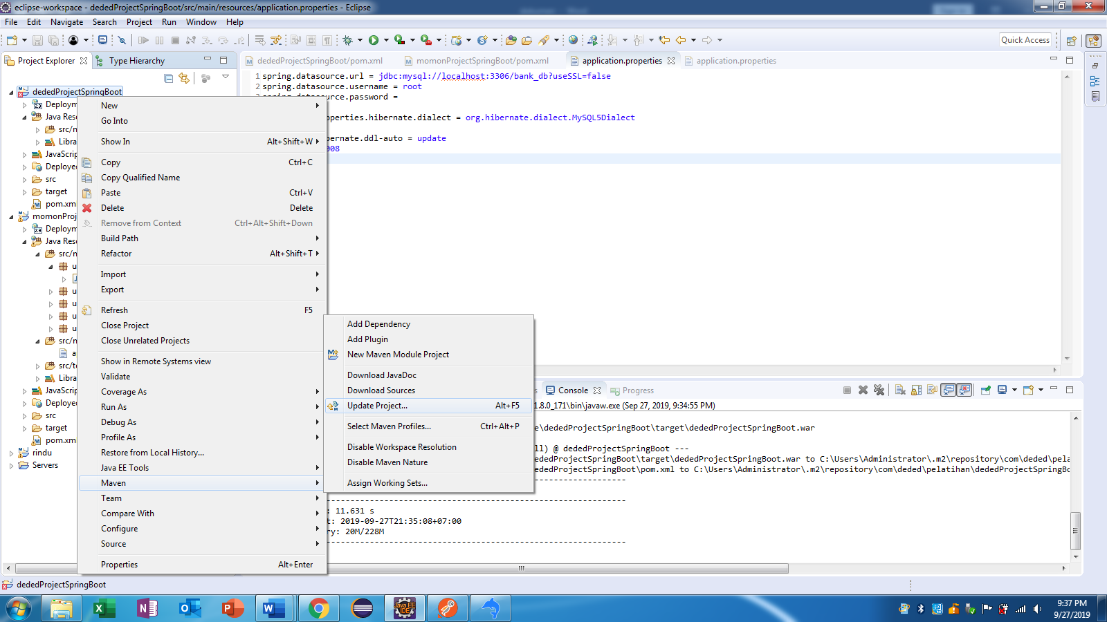

1. Bikin package src/main/java pada package Java Resources. Klik kanan project – properties – java build path. Ceklist maven dependencies dan JRE System Library – apply and close .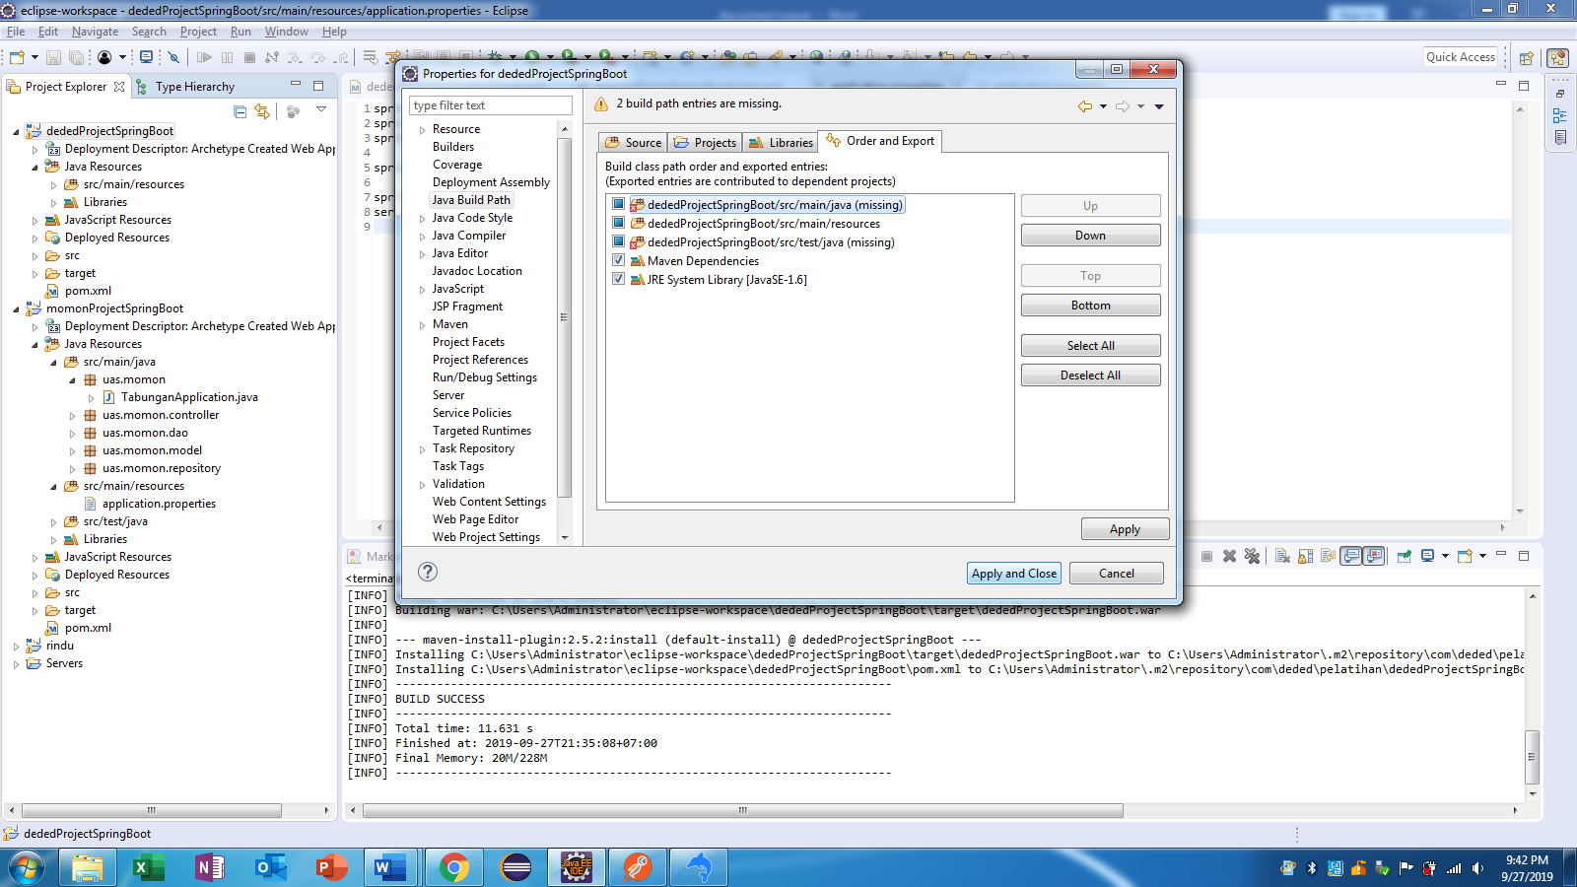
2. Bikin package untuk model.klik kanan java/src/main – new – class. Beri nama papckage = uas.deded.model name = TabunganModel

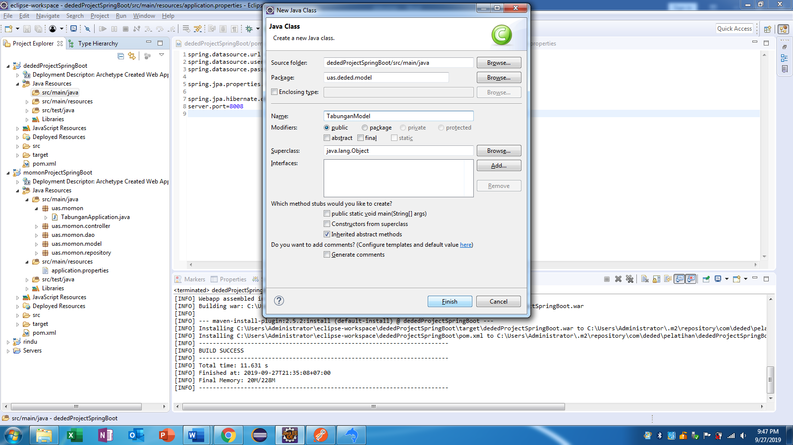

Kodingan pada TabunganModel.java

**package** uas.deded.model;

**import** java.util.Date;

**import** javax.persistence.Entity;

**import** javax.persistence.EntityListeners;

**import** javax.persistence.GeneratedValue;

**import** javax.persistence.GenerationType;

**import** javax.persistence.Id;

**import** javax.persistence.Table;

**import** javax.persistence.Temporal;

**import** javax.persistence.TemporalType;

**import** org.hibernate.validator.constraints.NotBlank;

**import** org.springframework.data.annotation.LastModifiedDate;

**import** org.springframework.data.jpa.domain.support.AuditingEntityListener;

@Entity

@Table(name="tabungan_tbl")

@EntityListeners(AuditingEntityListener.**class**)

**public** **class** TabunganModel {

@Id

@GeneratedValue(strategy=GenerationType.***AUTO***)

**private** Long id;

@NotBlank

**private** String nik, nama;

**private** Integer saldo, kredit, debet;

@LastModifiedDate

@Temporal(TemporalType.***TIMESTAMP***)

**private** Date createTime;

**public** Long getId() {

**return** id;

}

**public** **void** setId(Long id) {

**this**.id = id;

}

**public** String getNik() {

**return** nik;

}

**public** **void** setNik(String nik) {

**this**.nik = nik;

}

**public** String getNama() {

**return** nama;

}

**public** **void** setNama(String nama) {

**this**.nama = nama;

}

**public** Integer getSaldo() {

**return** saldo;

}

**public** **void** setSaldo(Integer saldo) {

**this**.saldo = saldo;

}

**public** Integer getKredit() {

**return** kredit;

}

**public** **void** setKredit(Integer kredit) {

**this**.kredit = kredit;

}

**public** Integer getDebet() {

**return** debet;

}

**public** **void** setDebet(Integer debet) {

**this**.debet = debet;

}

**public** Date getCreateTime() {

**return** createTime;

}

**public** **void** setCreateTime(Date createTime) {

**this**.createTime = createTime;

}

}

1. Bikin package untuk repository. klik kanan java/src/main – new – class. Beri nama papckage = uas.deded.repository name = TabunganRepository

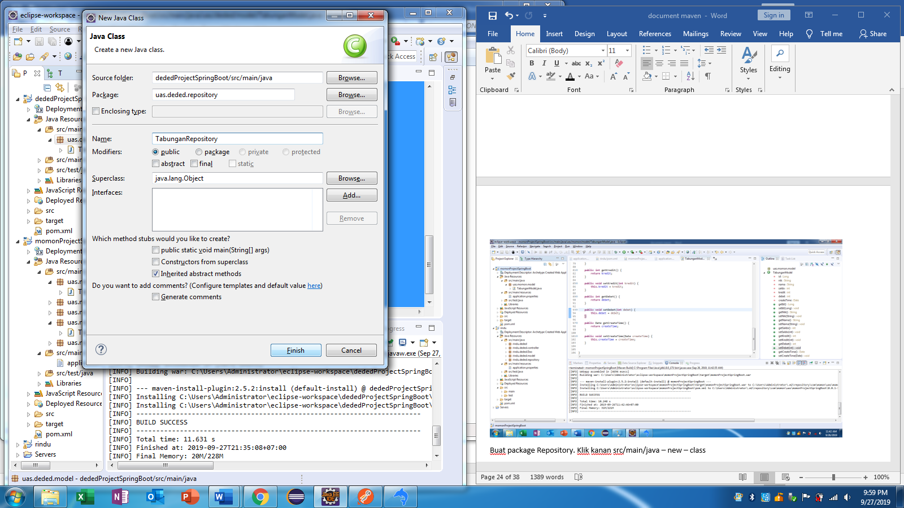

Ganti class menjadi interface

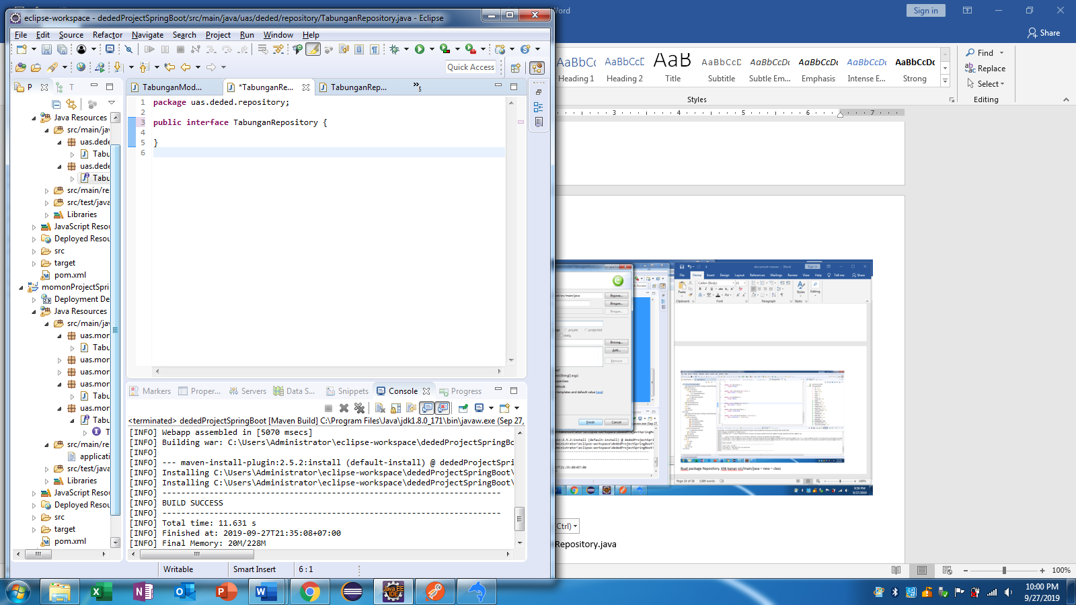

Kodingan pada TabunganRepository.java

**package** uas.deded.repository;

**import** java.util.List;

**import** org.springframework.data.jpa.repository.JpaRepository;

**import** org.springframework.data.jpa.repository.Query;

**import** org.springframework.data.repository.query.Param;

**import** uas.deded.model.TabunganModel;

**public** **interface** TabunganRepository **extends** JpaRepository<TabunganModel, Long>{

@Query(value="select *from tabungan_tbl where nik =:nik", nativeQuery = **true**)

List<TabunganModel> getDataByNik(@Param("nik")String nik);

@Query(value="SELECT *FROM tabungan_tbl WHERE nik =:nik ORDER BY id DESC LIMIT 1", nativeQuery = **true**)

TabunganModel getLastSaldo(@Param("nik")String nik);

}

1. Bikin package untuk DAO. klik kanan java/src/main – new – class. Beri nama papckage = uas.deded.dao name = TabunganDao

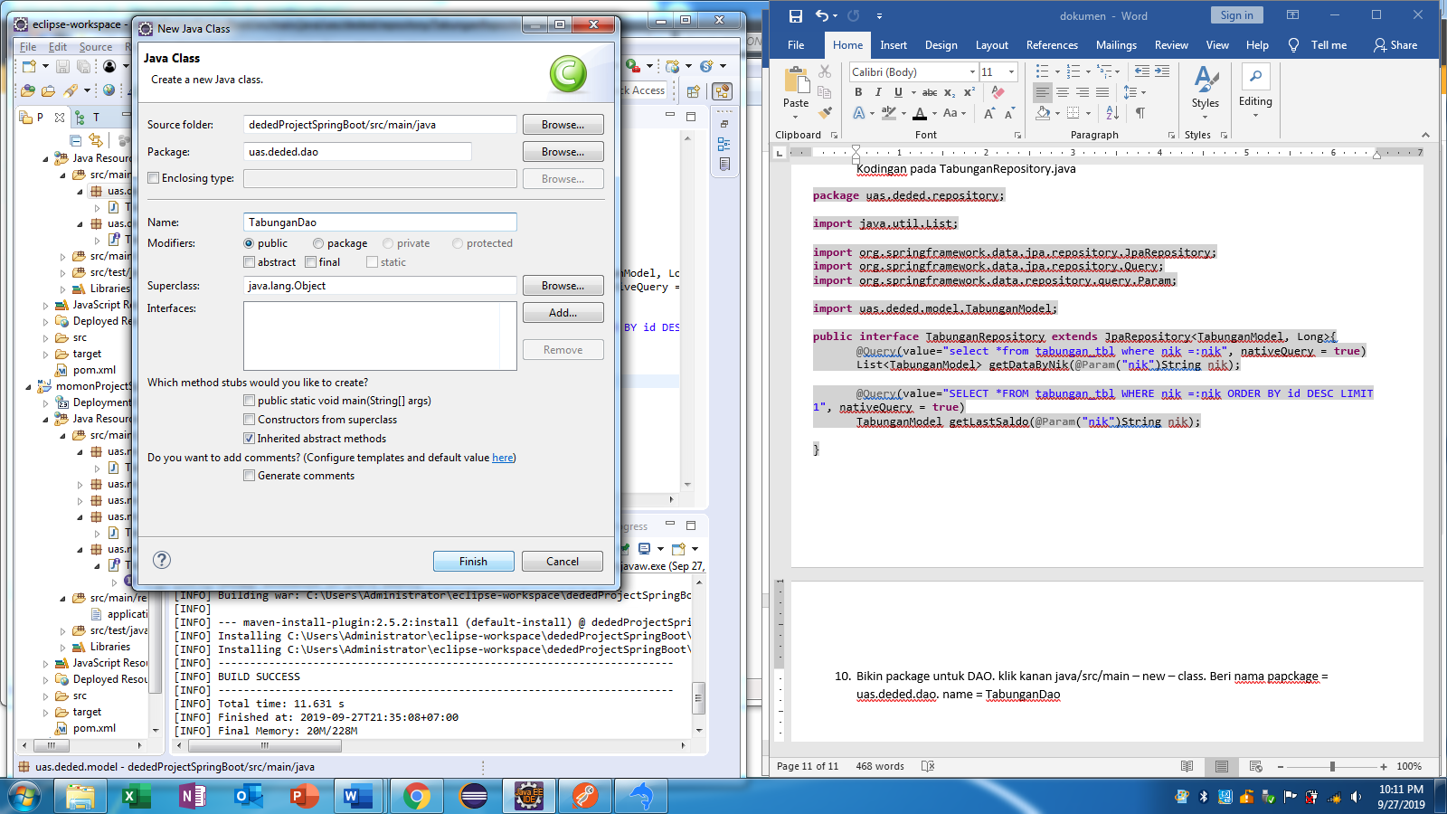

Kodingan pada TabunganDao.java

package uas.deded.dao;

import java.util.List;

import org.springframework.beans.factory.annotation.Autowired;

import org.springframework.stereotype.Service;

import uas.deded.model.TabunganModel;

import uas.deded.repository.TabunganRepository;

@Service

public class TabunganDao {

@Autowired

TabunganRepository tabunganRepository;

//create

public TabunganModel save(TabunganModel tabunganModel) {

TabunganModel tab1 = tabunganModel;

TabunganModel tab2 = tabunganRepository.getLastSaldo(tab1.getNik());

if(tab2==null) {

tab1.setSaldo(0 + tab1.getKredit() - tab1.getDebet());

return tabunganRepository.save(tab1);

}else {

tab1.setSaldo(tab2.getSaldo() + tab1.getKredit() - tab1.getDebet());

return tabunganRepository.save(tab1);

}

}

//read all

public List<TabunganModel> getAll(){

return tabunganRepository.findAll();

}

//read by id

public TabunganModel getDataById(Long id) {

return tabunganRepository.findOne(id);

}

//read by nik

public List<TabunganModel> getDataByNik(String nik){

return tabunganRepository.getDataByNik(nik);

}

//update

public TabunganModel update(TabunganModel tabunganModel) {

TabunganModel tab1 = tabunganModel;

TabunganModel tab2 = tabunganRepository.findOne(tab1.getId());

tab2.setSaldo(tab2.getSaldo()+tab1.getKredit()-tab1.getDebet());

tab2.setDebet(tab1.getDebet());

tab2.setKredit(tab1.getKredit());

Integer tamp = tab2.getSaldo();

List<TabunganModel> tampp = tabunganRepository.getDataByNik(tab1.getNik());

for(TabunganModel data : tampp) {

if(data.getId() > tab1.getId()) {

TabunganModel tab3 = tabunganRepository.findOne(data.getId());

tab3.setSaldo(tamp + tab3.getKredit() - tab3.getDebet());

tabunganRepository.save(tab3);

tamp=tab3.getSaldo();

}

}

return tabunganRepository.save(tab2);

}

// delete

public void delete(long id) {

TabunganModel tab1 = tabunganRepository.findOne(id);

int tamp = tab1.getSaldo()-tab1.getKredit()+tab1.getDebet();

List<TabunganModel> tampp=tabunganRepository.getDataByNik(tab1.getNik());

for(TabunganModel data:tampp) {

if(data.getId()>tab1.getId()) {

TabunganModel tab2=tabunganRepository.findOne(data.getId());

tab2.setSaldo(tamp+tab2.getKredit()-tab2.getDebet());

tabunganRepository.save(tab2);

tamp=tab2.getSaldo();

}

}

tabunganRepository.delete(id);

}

}

1. Buat package controller. klik kanan java/src/main – new – class. Beri nama papckage = uas.deded.controller name = TabunganController

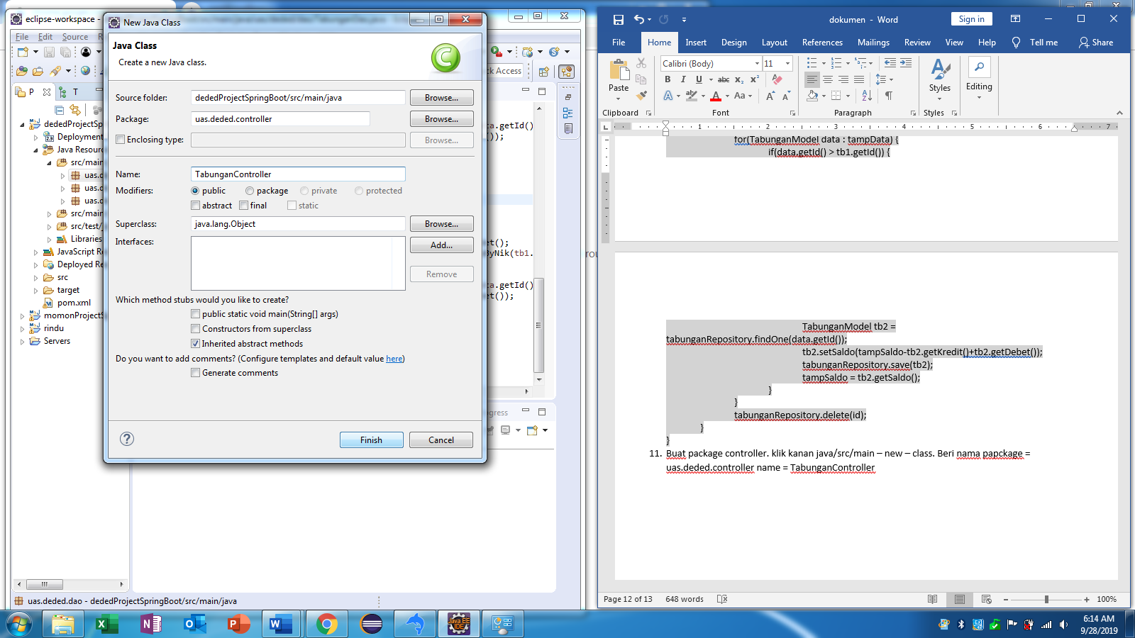

Kodingan pada TabunganController.java

package uas.deded.controller;

import java.util.List;

import javax.validation.Valid;

import org.springframework.beans.factory.annotation.Autowired;

import org.springframework.http.ResponseEntity;

import org.springframework.web.bind.annotation.DeleteMapping;

import org.springframework.web.bind.annotation.GetMapping;

import org.springframework.web.bind.annotation.PathVariable;

import org.springframework.web.bind.annotation.PostMapping;

import org.springframework.web.bind.annotation.PutMapping;

import org.springframework.web.bind.annotation.RequestBody;

import org.springframework.web.bind.annotation.RequestMapping;

import org.springframework.web.bind.annotation.RestController;

import uas.deded.dao.TabunganDao;

import uas.deded.model.TabunganModel;

@RestController

@RequestMapping("/bank")

public class TabunganController {

@Autowired

TabunganDao tabunganDao;

//create

@PostMapping("/simpan")

public TabunganModel saveTabungan(@Valid @RequestBody TabunganModel tabunganModel) {

return tabunganDao.save(tabunganModel);

}

//read all

@GetMapping("/lihatSemua")

public List<TabunganModel> getAll(){

return tabunganDao.getAll();

}

//read by id

@GetMapping("/lihatById/{id}")

public ResponseEntity<TabunganModel> getDataById(@PathVariable(value="id")Long id){

TabunganModel tab = tabunganDao.getDataById(id);

if(tab == null) {

return ResponseEntity.notFound().build();

}else {

return ResponseEntity.ok().body(tab);

}

}

//read by nik

@GetMapping("/lihatByNik/{nik}")

public List<TabunganModel> getDataByNik(@PathVariable(value="nik")String nik){

return tabunganDao.getDataByNik(nik);

}

//update

@PutMapping("/ubah/{id}")

public ResponseEntity<TabunganModel> update(@PathVariable(value="id")Long id, @Valid @RequestBody TabunganModel tabunganModel){

TabunganModel tab1=tabunganDao.getDataById(id);

if(tab1==null) {

return ResponseEntity.notFound().build();

}else {

tab1.setSaldo(tab1.getSaldo()-tab1.getKredit()+tab1.getDebet());

tab1.setDebet(tabunganModel.getDebet());

tab1.setKredit(tabunganModel.getKredit());

TabunganModel hasil=tabunganDao.update(tab1);

return ResponseEntity.ok().body(hasil);

}

}

//delete

@DeleteMapping("/hapus/{id}")

public ResponseEntity<TabunganModel> delet(@PathVariable(value="id")Long id){

TabunganModel tab1 = tabunganDao.getDataById(id);

if(tab1==null) {

return ResponseEntity.notFound().build();

}else {

tabunganDao.delete(id);

return ResponseEntity.ok().build();

}

}

}

1. Buat package Main. Klik kanan src/main/java – new – class

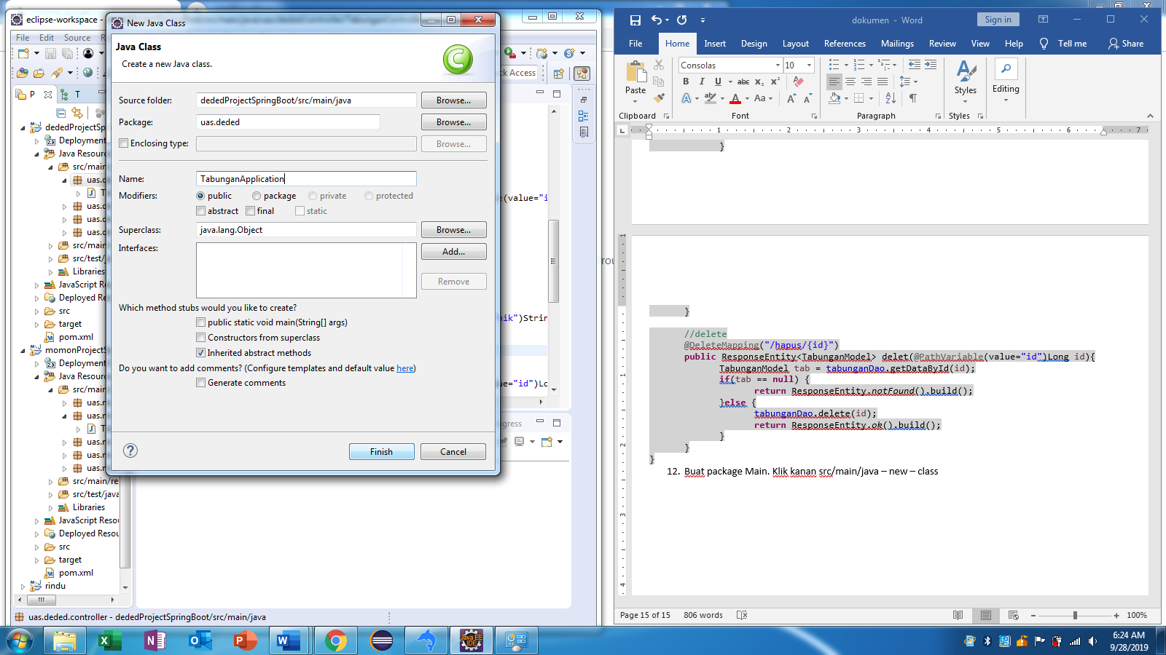

Kodingan pada TabunganApplication.java

**package** uas.deded;

**import** org.springframework.boot.SpringApplication;

**import** org.springframework.boot.autoconfigure.SpringBootApplication;

**import** org.springframework.data.jpa.repository.config.EnableJpaAuditing;

@SpringBootApplication

@EnableJpaAuditing

**public** **class** TabunganApplication {

**public** **static** **void** main(String[] args) {

SpringApplication.*run*(TabunganApplication.**class**, args);

}

}

1. Ganti jre ke jdk. Klik kanan project – run as – run configuration – jre – klik alternate JRE – installed JREs – add – Standard VM – next – Directory – cari direksi menyimpan JDK(c:program files/java/jdk)

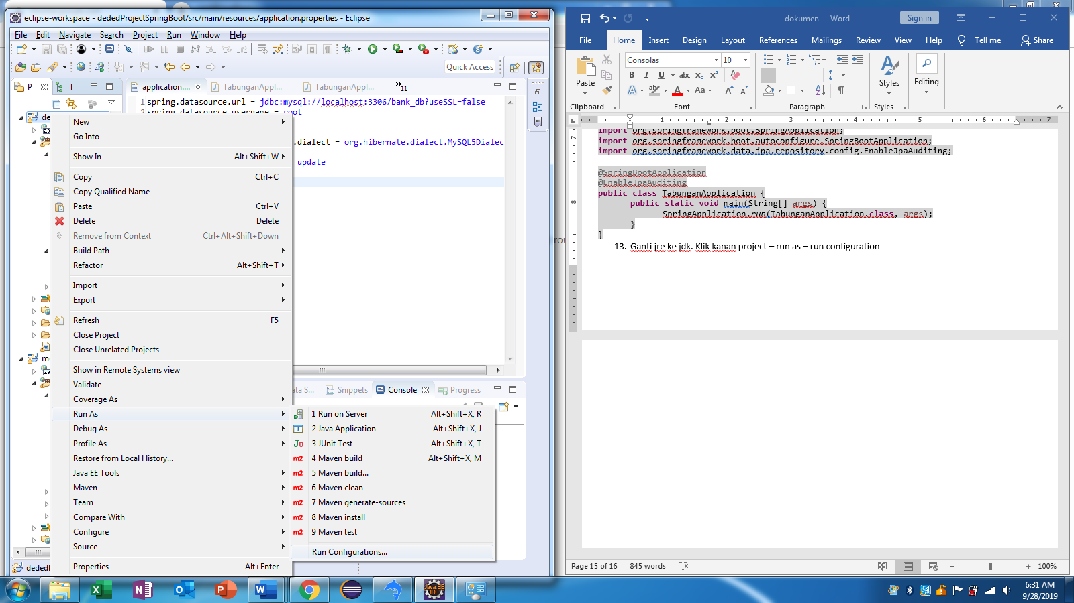ceklist jdk – apply and close

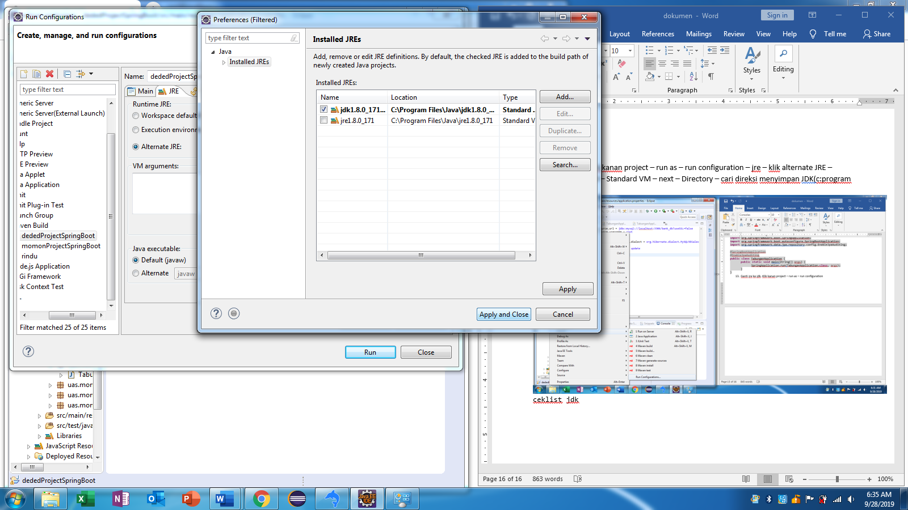

Run

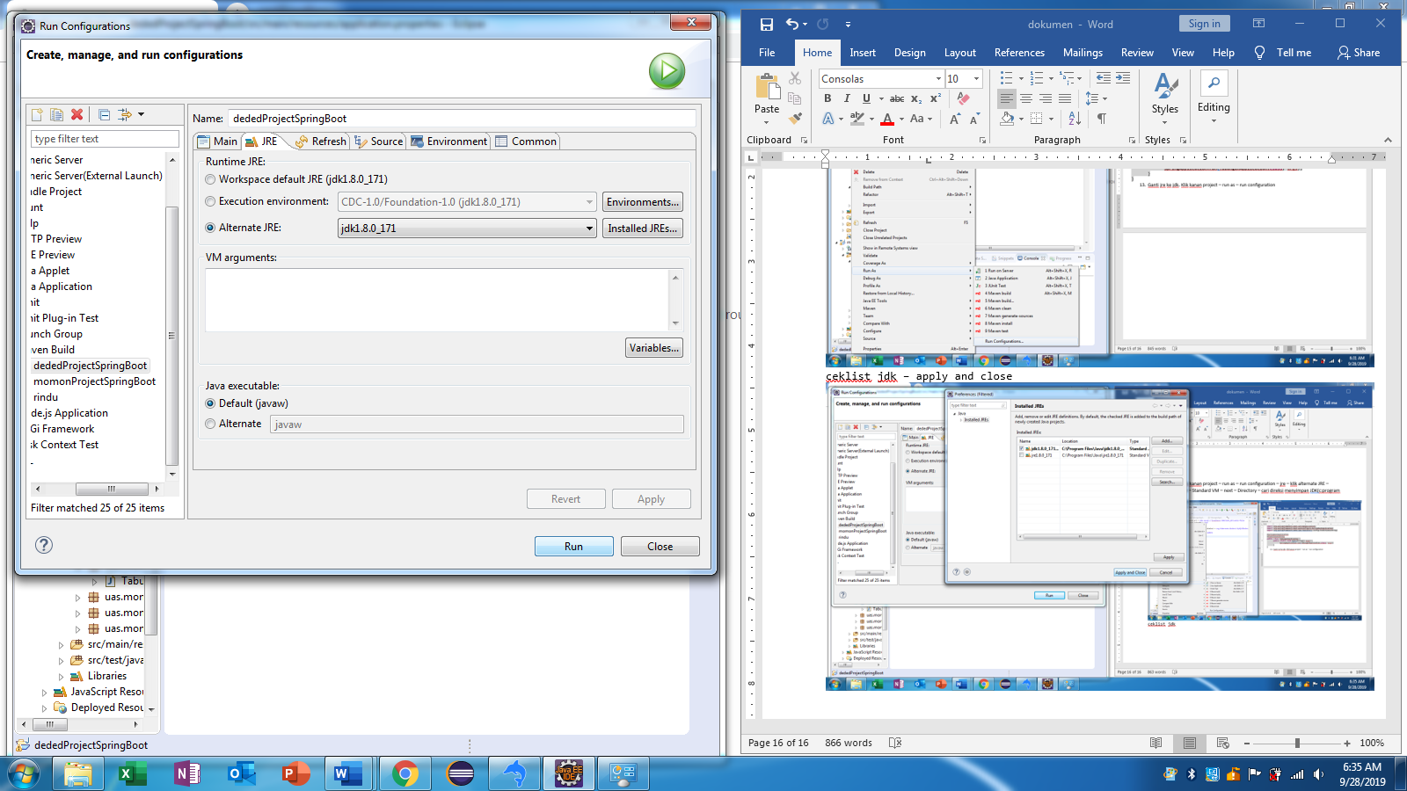

Output

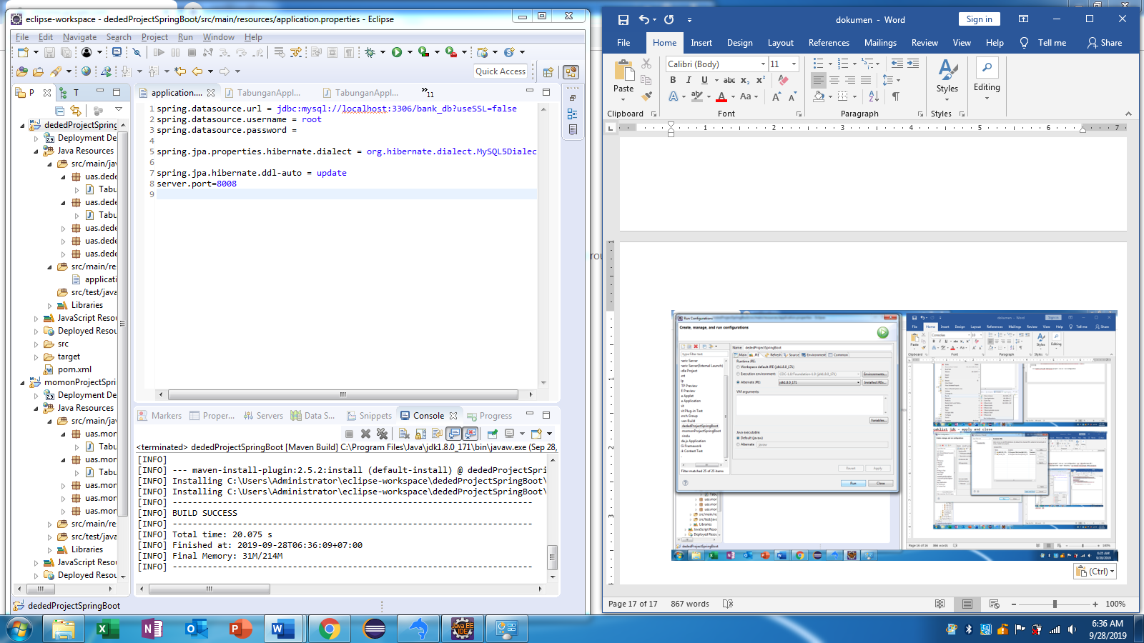

1. Setting tomcat server. Klik pada tab output pilih tab server-klik link dibawah.

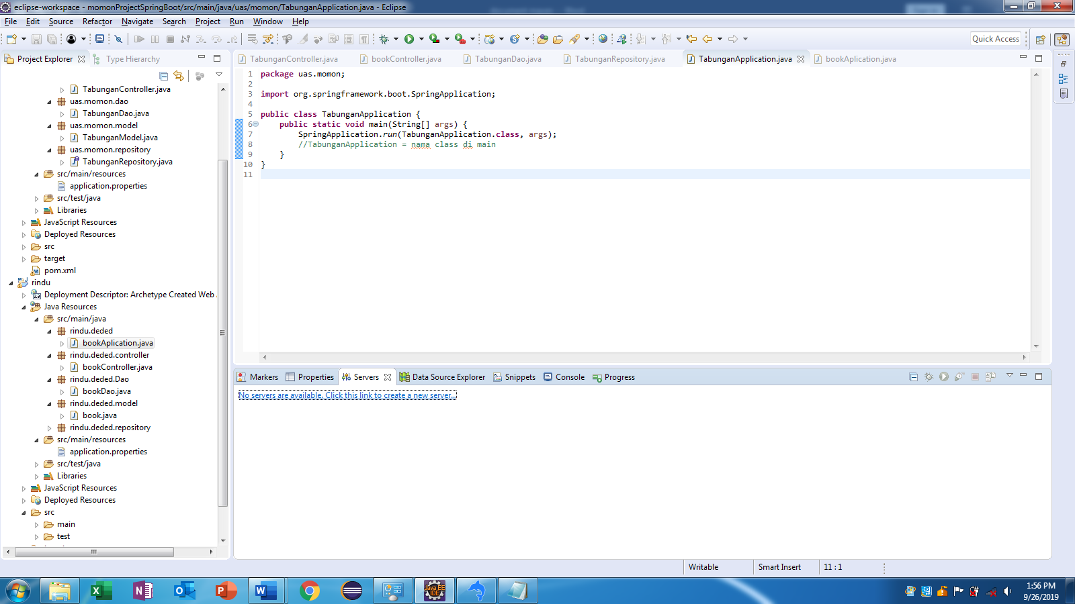

Muncul dan pilih tomcat 8.5 – next -

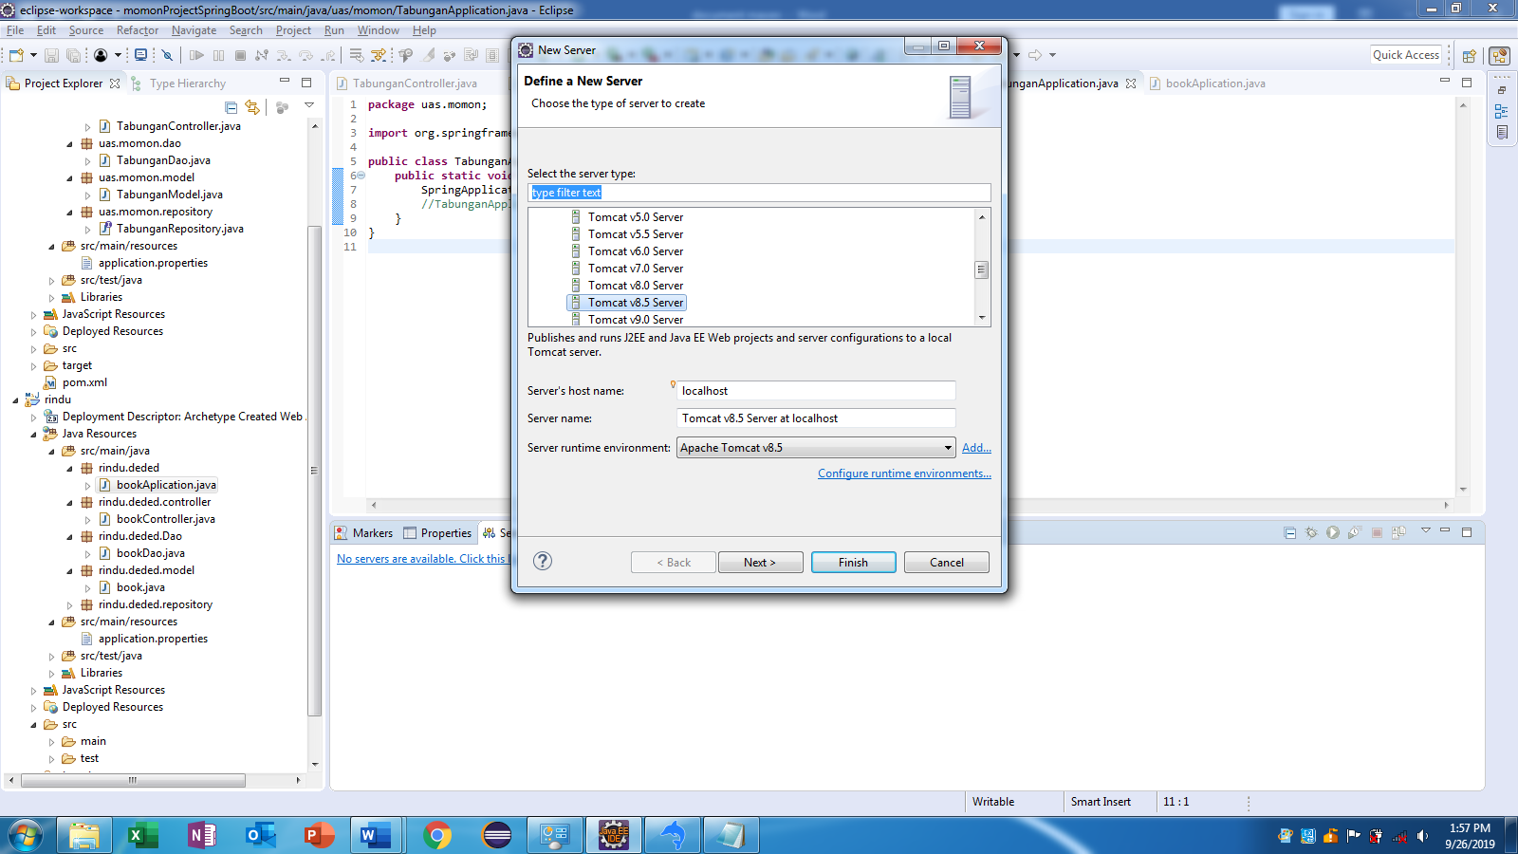

Pilih project kita – add - finish

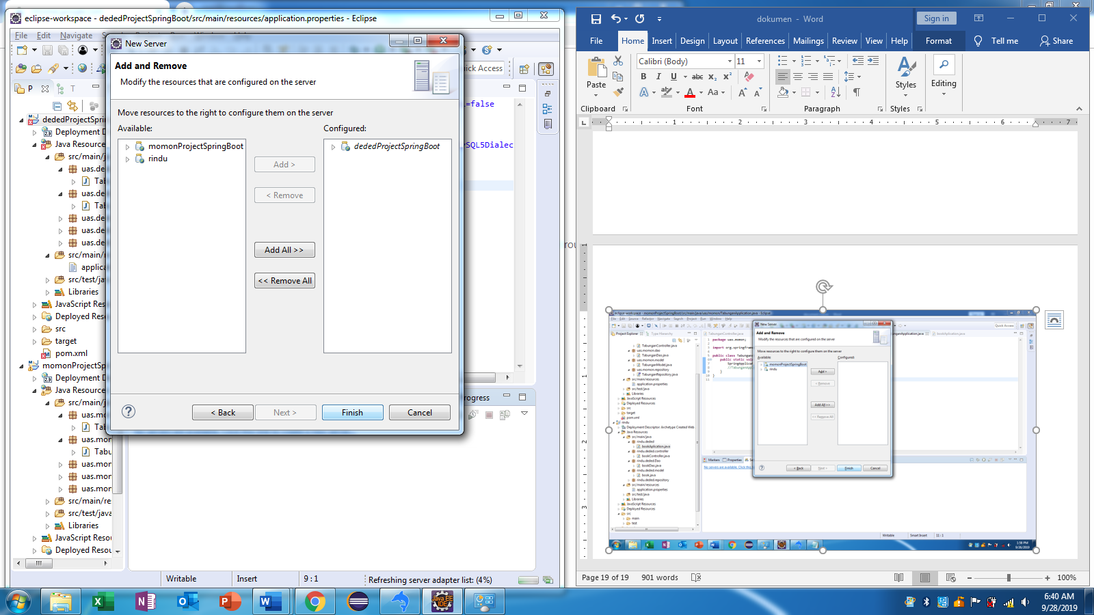

1. Run main. Klik kanan TabunganApplication – run as - java application

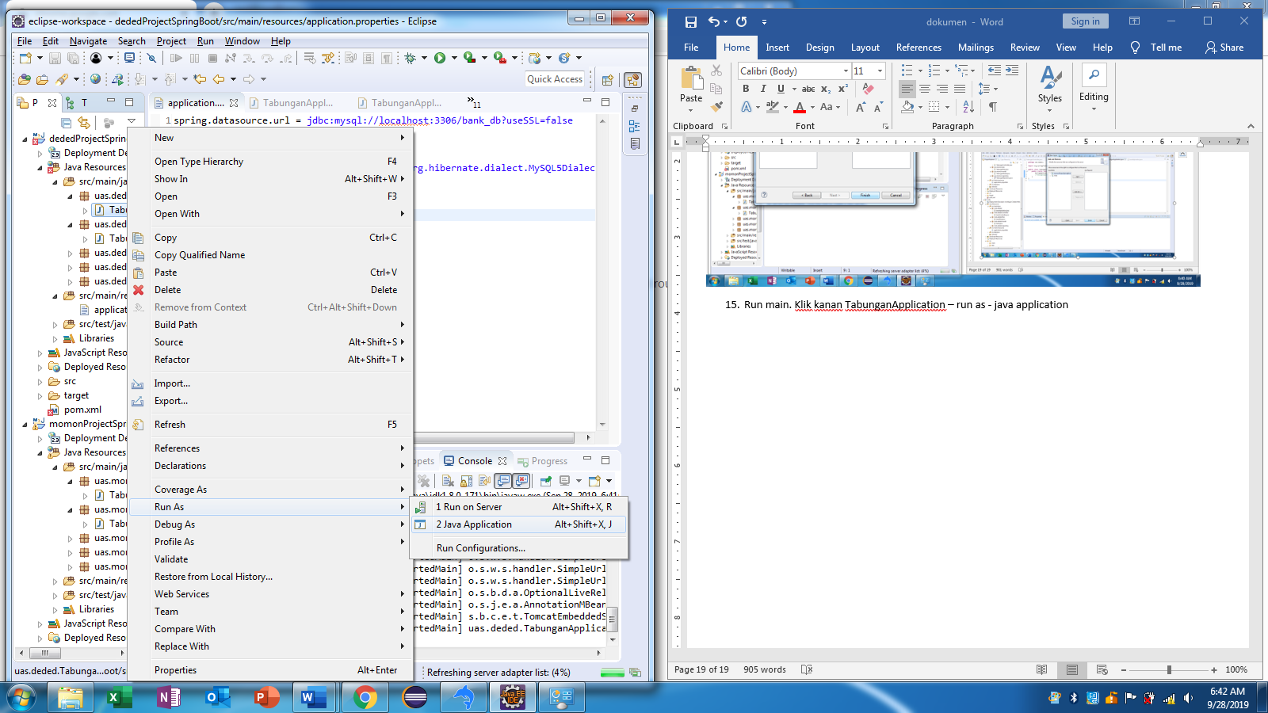

Output : started port

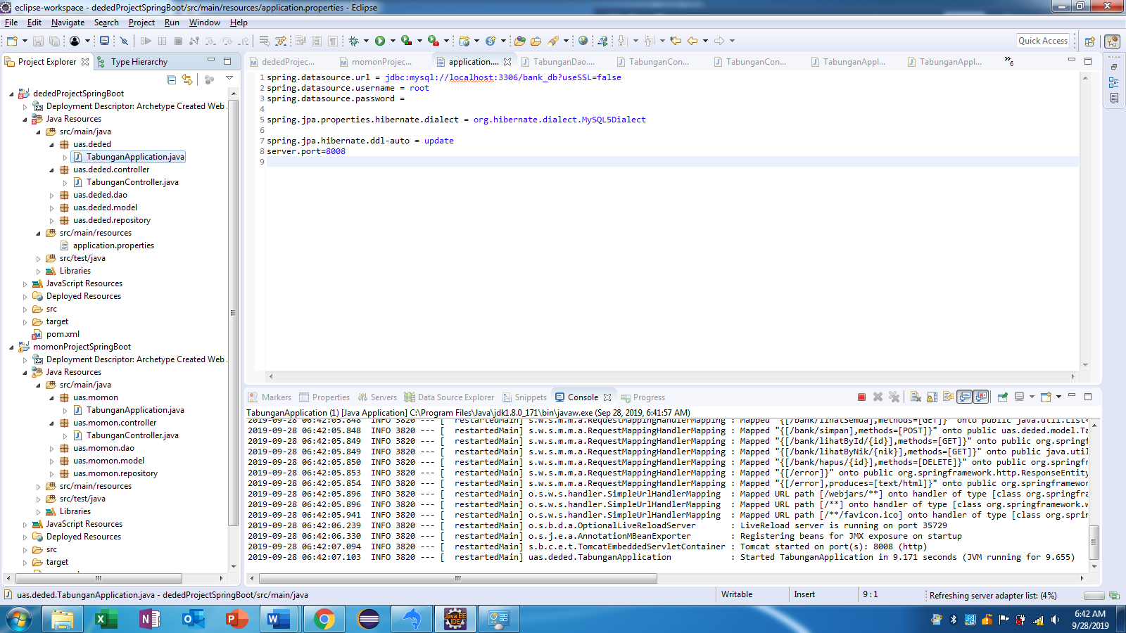

1. Buka postman.

* Create -> localhost:8008/bank/simpan

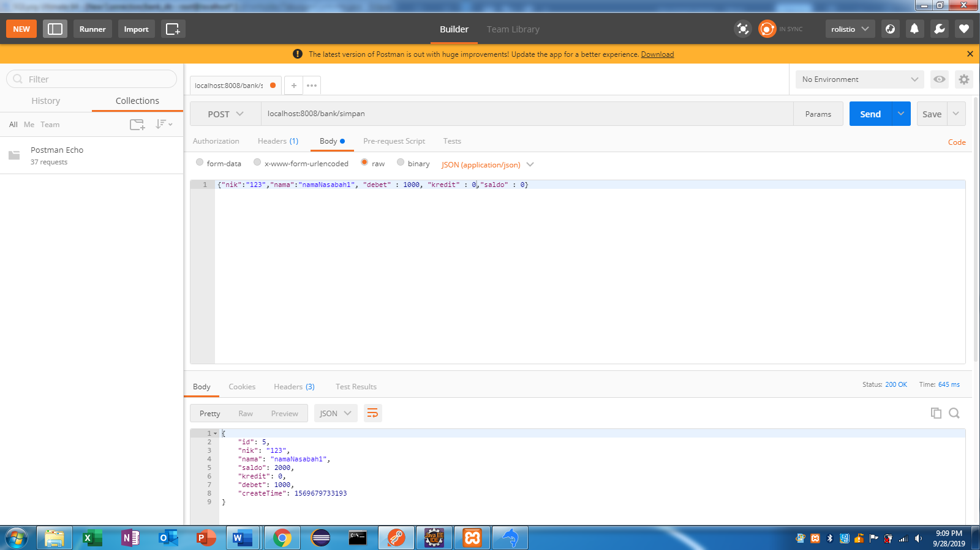

* Read all -> localhost:8008/bank/lihatSemua

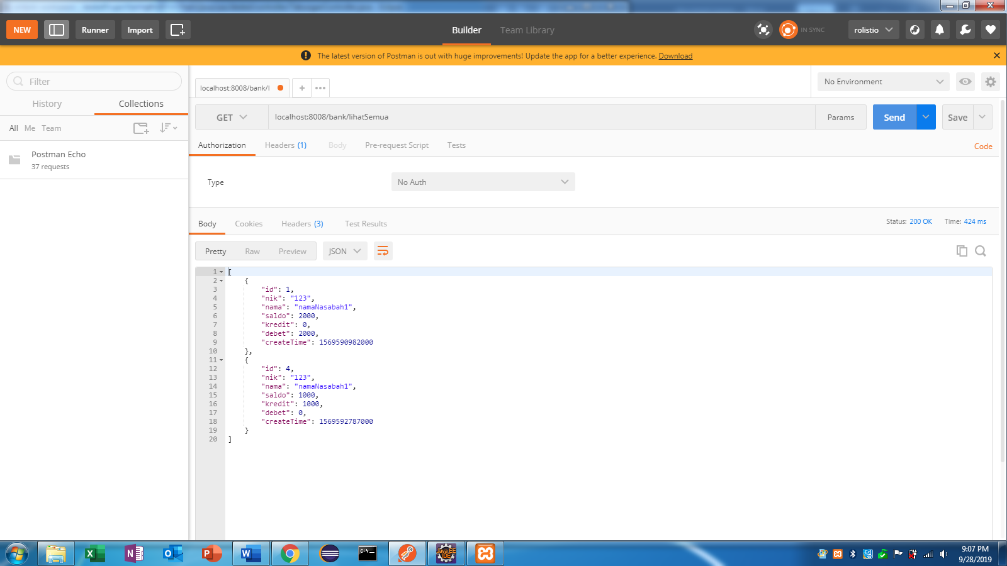

* Read by id -> localhost:8008/bank/lihatById/1

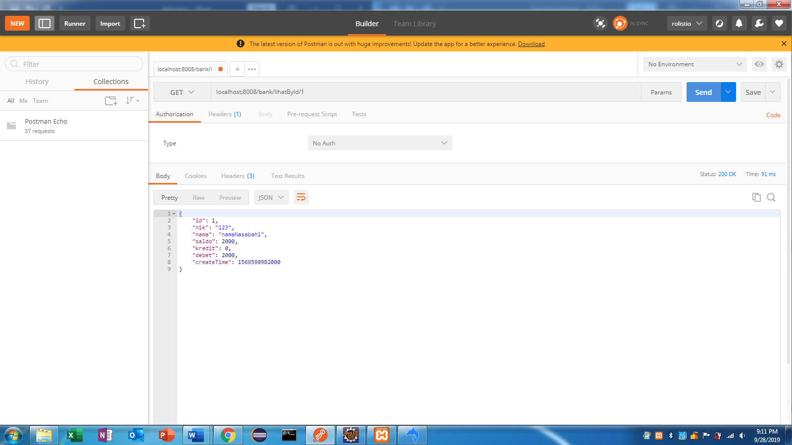

* Read by nik -> localhost:8008/bank/lihatByNik/123

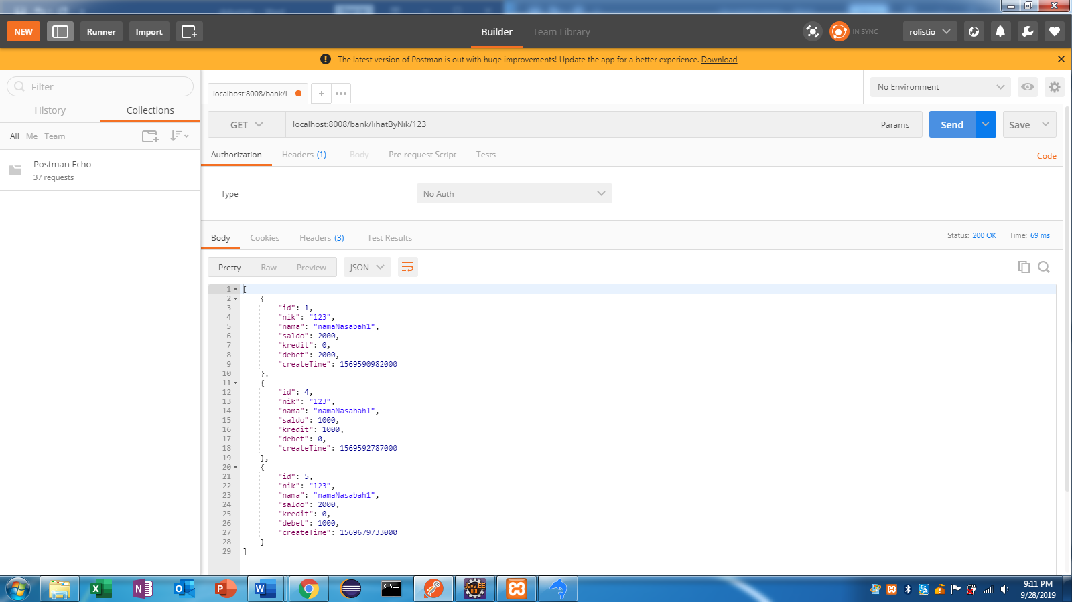

* Update -> localhost:8008/bank/ubah/4

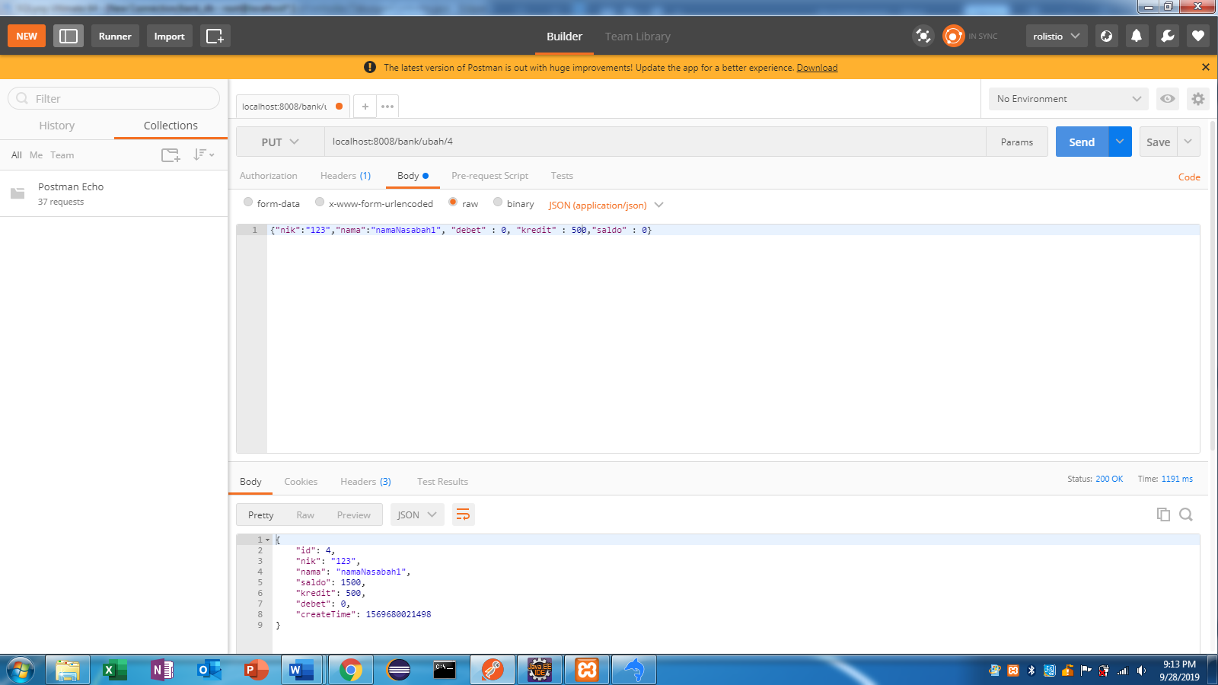

* Delete -> localhost:8008/bank/hapus/4

